**Yosemite National Park Visitor Forecast**

Tyki Wada

Analysis done as example, not for valid use or publication.

**Summary:**

In the last 10+ years, Yosemite National Park has been increasing exponentially in visitors. This report gives the predictions in visitors for the next 5 years and interpretation for past visitors.

The predictions are created with data from previous years using a Time Series method (in millions).

A short explanation of the Time Series analysis:

The Arima model, also known as the Box Jenkins method is the most general class of autoregressive model for forecasting a time series. This method takes each year and extrapolates forward using a Time Series prediction. The model assumes that only the previous year determines future years, which means that this prediction depends on a roughly constant change in operations, marketing strategies, weather conditions, and counting techniques. This report should not be used to determine exactly what our values may fall-between, but a benchmark indicating what would happen if the organizational process does not change.

As for the annual visitor’s data, the dataset was retrieved from the National Park’s service STATS website. A side by side comparison with the national park’s website will give a general idea of the happenings in the national parks and possible explanations for dips and spikes in park visitor numbers.

The information spans from the inception of the park up until the last calendar year, so the data only runs until 2016. A comparison with the 2017 value will subjectively validate the model’s predictability further.

**Data:**

Graphics for the park visitor-ship from 1950 up to 2016.

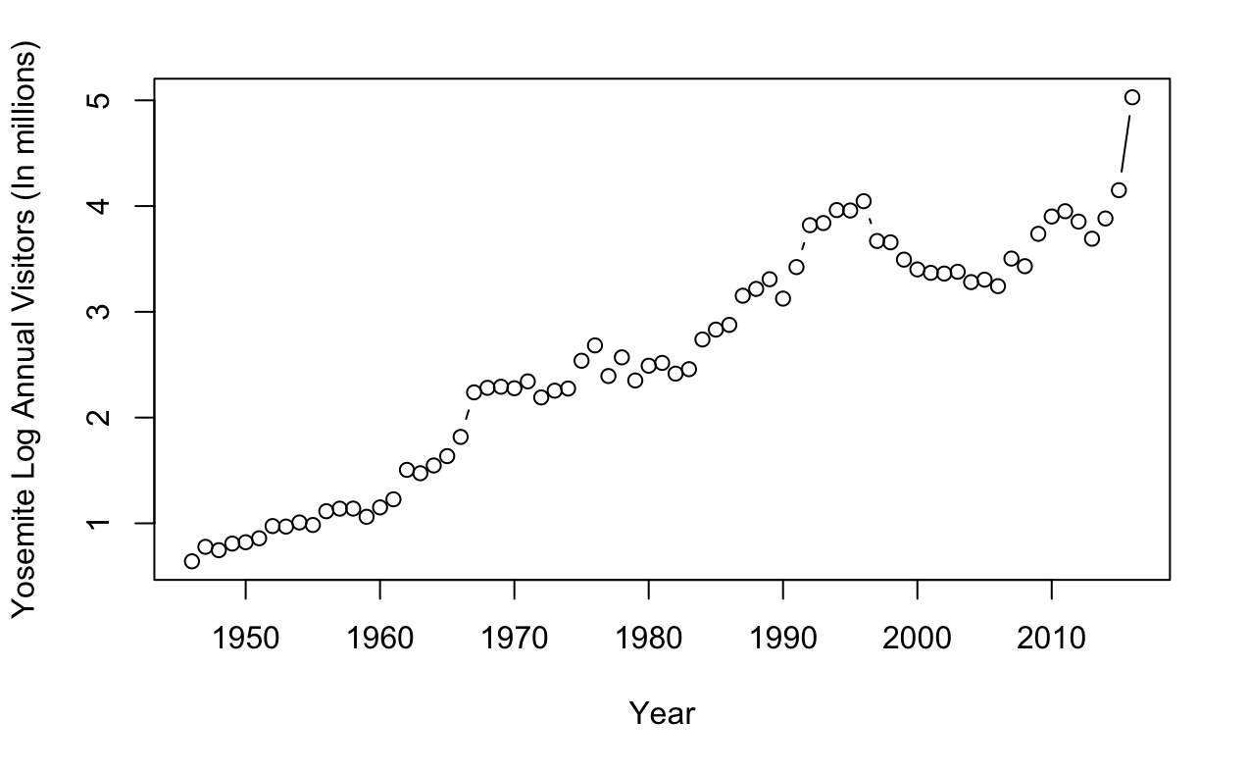

Table estimates with 95% confidence intervals along with the graphic of the prediction.

|  |  |  |  |
| --- | --- | --- | --- |
| 5-Year prediction (95% confidence) | | | |
| Year | **Parameter** | **Lower** | Upper |
| 2017 | **5.096657** | **4.472109** | 5.808425 |
| 2018 | **5.301227** | **4.446741** | 6.319912 |
| 2019 | **5.421584** | **4.366934** | 6.73094 |
| 2020 | **5.606032** | **4.376368** | 7.181205 |
| 2021 | 5.755369 | 4.362865 | 7.59232 |

Graphic for Forecasted Values for the next 5 years.

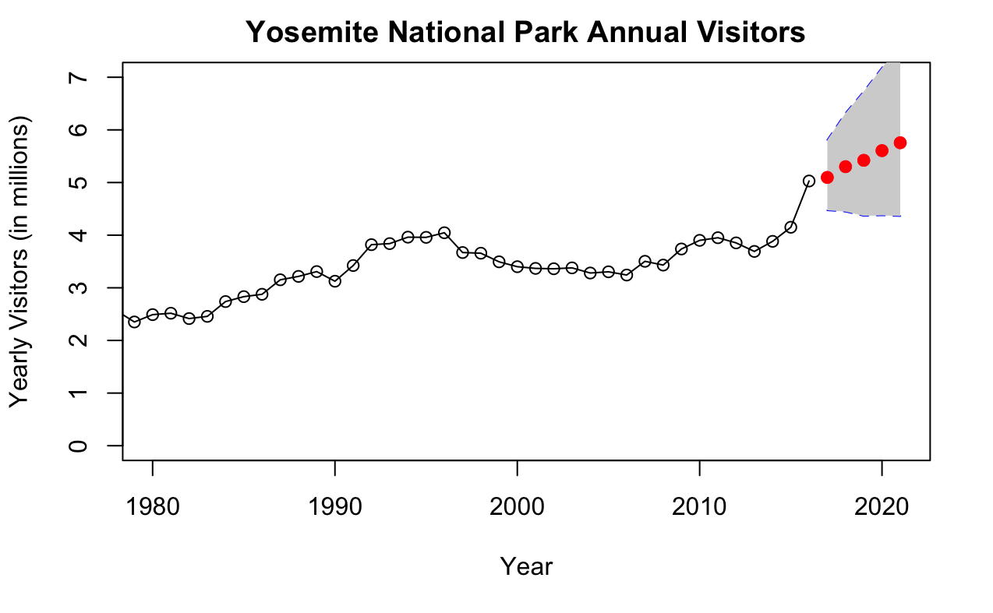

**Analysis:**

The trend shows an overall increase in expected visitors by close to 100-200 thousand visitors per year. This is offset by predictions within a large range of 2 million visitors. Yet, with recent trends of excitement amongst tourists, there is cause to be optimistic with the increase in viewership. At this rate park employment may need to increase to keep up in the coming years along with reconstruction to allow for increased tourism.

Please note that this forecast is dependent on roughly constant change in operations, marketing strategies, weather conditions, and counting techniques.

There are also viable concerns with global warming and weather patterns that will affect park snow and fire conditions and may impact overall visitor-ship. Close coordination with the environmental research team may be necessary for an in-depth analysis on safety hazards.

Better data collection is also advised as there are multiple untraced entrances that feed into the park. Overall, the recent trends show how there is steady growth which may not hold too much room for concern at this moment.

Data retrieved from:

[https://irma.nps.gov/Stats/SSRSReports/Park%20Specific%20Reports/](https://irma.nps.gov/Stats/SSRSReports/Park%20Specific%20Reports/Annual%20Park%20Recreation%20Visitation%20(1904%20-%20Last%20Calendar%20Year)?Park=YOSE)